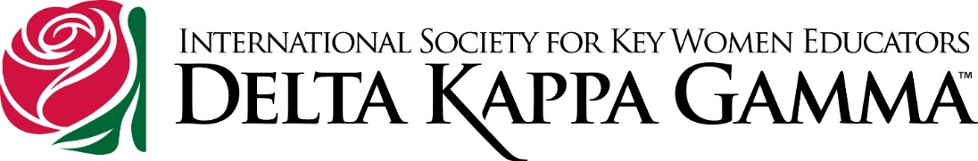
Member Media Usage Permission Form - Interactive
Use Tab to move between fields.
I, , hereby grant permission to
Chapter of Oregon State Organization to create, copy, reproduce, exhibit, publish or distribute my image, name and email address in chapter, state and international projects, publications, presentations and/or in public media.
I understand that the above uses may include but are not limited to video, photographs, websites, multimedia programs or other types of promotional media existing now or in the future. State and chapter websites especially, and all media listed above, must comply with DKG International Policies and Procedures for privacy and copyright issues.
I also grant permission for my home address, my mailing address and my phone number to be published in my chapter’s yearbook and possibly in Oregon State Organization’s Leadership Directory to be shared with members in our Chapter, and as needed with members around Oregon and in International.

Name (Please print if using a paper copy.) DOB

Address Phone

City, State, Postal Code Email

Date
Signature or E-Signature Using Your Member Number
Please return paper forms to the state administrative secretary.
Bonita Fillmore, 1803 Lancaster Ave., Klamath Falls, OR 97601
OR – Email this completed interactive form to bfillmore55@gmail.com.
Address questions to state president.

